CS 255 Business Requirements Document Template

Complete this template by replacing the bracketed text with the relevant information.

This template lays out all the different sections that you need to complete for Project One. Each section has guiding questions to prompt your thinking. These questions are meant to guide your initial responses to each area. You are encouraged to go beyond these questions using what you have learned in your readings. You will need to continually reference the interview transcript as you work to make sure that you are addressing your client’s needs. There is no required length for the final document. Instead, the goal is to complete each section based on your client’s needs.

Tip: You should respond in a bulleted list for each section. This will make your thoughts easier to reference when you move into the design phase for Project Two. One starter bullet has been provided for you in each section, but you will need to add more.

System Components and Design

Purpose
What is the purpose of this project? Who is the client and what do they want their system to be able to do?
= The purpose of this project is to design a system for DriverPass that helps students pass their driving tests more effectively. DriverPass (the client) wants a system that provides online practice exams and scheduling for driving lessons. The system should improve student success rates and provide a structured learning experience.

System Background
What does DriverPass want the system to do? What is the problem they want to fix? What are the different components needed for this system?
= DriverPass noticed that over 65% of students fail driving tests because they only study old exam questions. The company wants to fix this by:
- Providing updated DMV-based practice tests
- Offering on-the-road driving training
The system will include:
- User accounts (students, instructors, admin)
- Scheduling system for lessons
- Online testing platform
- Database to store user progress and results

Objectives and Goals
What should this system be able to do when it is completed? What measurable tasks need to be included in the system design to achieve this?
= The system should:
- Help students prepare using realistic practice exams
- Allow students to schedule driving lessons easily
- Track progress and performance over time
- Provide admin control for managing users and content

Measurable goals:
- Reduce the failure rate of students
- Ensure system uptime and accessibility
- Provide accurate and updated test content

Requirements

Nonfunctional Requirements
In this section, you will detail the different nonfunctional requirements for the DriverPass system. You will need to think about the different things that the system needs to function properly.

Performance Requirements
What environments (web-based, application, etc.) does this system need to run in? How fast should the system run? How often should the system be updated?
= The system should be web-based and available 24/7. Pages should load quickly (within 2–3 seconds). The system should support multiple users at the same time. And also test content should be updated regularly to match DMV standards.

Platform Constraints
What platforms (Windows, Unix, etc.) should the system run on? Does the back end require any tools, such as a database, to support this application?
= The system should work on:
- Windows and Mac computers
- Mobile devices (iOS and Android)
A backend database (like MySQL) is required
Internet access is required for all users

Accuracy and Precision
How will you distinguish between different users? Is the input case-sensitive? When should the system inform the admin of a problem?
=
- Each user must have a unique account. Input is case-sensitive
- The system should accurately track:
  - Test scores
  - Lesson schedules
- Admin should be notified if:
  - System errors occur
  - Data fails to save properly

Adaptability
Can you make changes to the user (add/remove/modify) without changing code? How will the system adapt to platform updates? What type of access does the IT admin need?
=
Admin should be able to: Add, remove, or update users without coding.
The system should be flexible for future updates
IT staff should have full access for maintenance and updates

Security
What is required for the user to log in? How can you secure the connection or the data exchange between the client and the server? What should happen to the account if there is a “brute force” hacking attempt? What happens if the user forgets their password?

= Firstly, users must log in with a username and password to access their accounts. The system should use encryption (like HTTPS) to protect data when it is being sent between the client and the server. If there is a brute force hacking attempt (too many wrong login attempts), the account should be temporarily locked to prevent unauthorized access. The system should also notify the user about suspicious activity. If a user forgets their password, they should be able to reset it using a secure method, such as email verification or a reset link.

Functional Requirements
Using the information from the scenario, think about the different functions the system needs to provide. Each of your bullets should start with “The system shall . . .” For example, one functional requirement might be, “The system shall validate user credentials when logging in.”
=
The system shall allow users to create and manage accounts
The system shall validate user login credentials when logging in
The system shall provide online practice driving tests
The system shall store and track user test scores and progress
The system shall allow users to schedule driving lessons
The system shall allow instructors to manage lesson schedules
The system shall allow administrators to manage users and system data
The system shall update test content based on DMV changes
The system shall provide feedback after each practice test

User Interface
What are the needs of the interface? Who are the different users for this interface? What will each user need to be able to do through the interface? How will the user interact with the interface (mobile, browser, etc.)?

= The system should have a simple and easy-to-use interface so all users can understand it without confusion. There will be three main users: students, instructors, and administrators. Students should be able to take tests, check scores, and schedule lessons. Instructors should be able to view schedules and manage lessons. Admins should be able to manage users and system settings. The system should be accessible through a web browser and also work on mobile devices for convenience.

Assumptions
What things were not specifically addressed in your design above? What assumptions are you making in your design about the users or the technology they have?
=
It is assumed that users have access to the internet.
It is assumed that users have basic knowledge of using a website or app.
It is assumed that DMV test content will be updated regularly.
It is assumed that instructors are available for scheduling lessons.

Limitations
Any system you build will naturally have limitations. What limitations do you see in your system design? What limitations do you have as far as resources, time, budget, or technology?
=
The system depends on internet access, so it may not work offline. Limited budget and time may affect how many features can be included. Security risks can be reduced but not completely eliminated. The system may not support all devices equally at the beginning.

Gantt Chart
Please include a screenshot of the GANTT chart that you created with Lucidchart. Be sure to check that it meets the plan described by the characters in the interview.

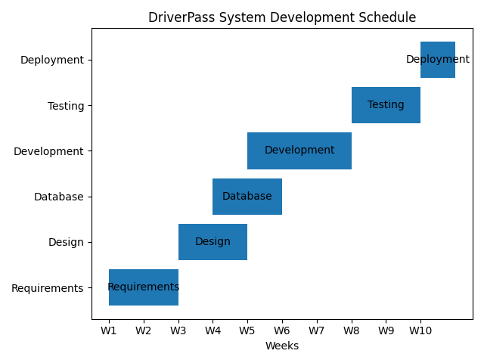
This Gantt chart presents a realistic 10-week development schedule for the DriverPass system based on task prioritization, dependencies, and time allocation. The project begins with requirements gathering, followed by system and database design. Development takes the longest time because it includes building the main system features. After development, testing ensures the system works correctly before final deployment.

